**Order Management API Documentation**

REST endpoints:

  GET - https://15k7wa6k5h.execute-api.us-east-1.amazonaws.com/dev/orders

  GET - https://15k7wa6k5h.execute-api.us-east-1.amazonaws.com/dev/orders/{id}

  POST - https://15k7wa6k5h.execute-api.us-east-1.amazonaws.com/dev/orders

  DELETE - https://15k7wa6k5h.execute-api.us-east-1.amazonaws.com/dev/orders/{id}

**REST API to add/ show and delete orders**

**Adding an order:**

curl -X POST https://15k7wa6k5h.execute-api.us-east-1.amazonaws.com/dev/orders -d '{"name": "Tea", "price": 6.00}'

{"id":"1785f486-479b-45b0-88aa-c0ae01a97969","name":"Tea","price":6.0}

**Listing all the orders:**

abhinaya-mbp:su18-202-py abhinaya$ curl https://15k7wa6k5h.execute-api.us-east-1.amazonaws.com/dev/orders

[{"id":"b3e48572-9db5-4749-b8d7-8fa562bf3f6c","name":"Cappuchino","price":11.5},{"id":"1785f486-479b-45b0-88aa-c0ae01a97969","name":"Tea","price":6.0},{"id":"22fef696-49a9-4fa0-abe7-8ec8108a745b","name":"Latte","price":7.5},{"id":"27e1de63-194a-43e1-a918-c21adc75e6db","name":"Chai-Latte","price":8.5}]

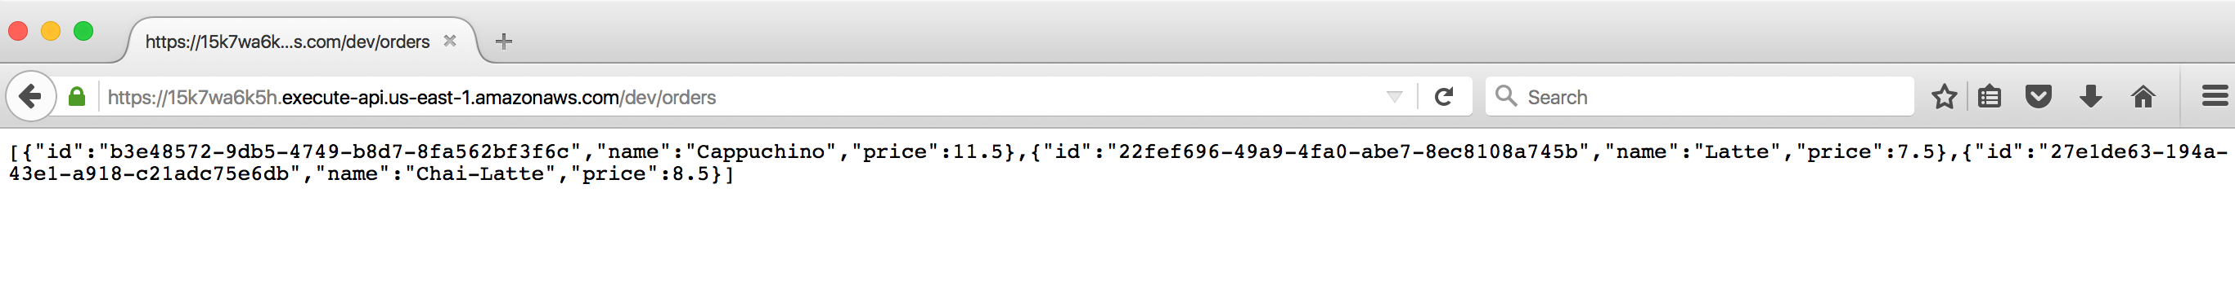

**Deleting an order**

curl -X DELETE <https://15k7wa6k5h.execute-api.us-east-1.amazonaws.com/dev/orders/1785f486-479b-45b0-88aa-c0ae01a97969>

**To list an order based on order id**

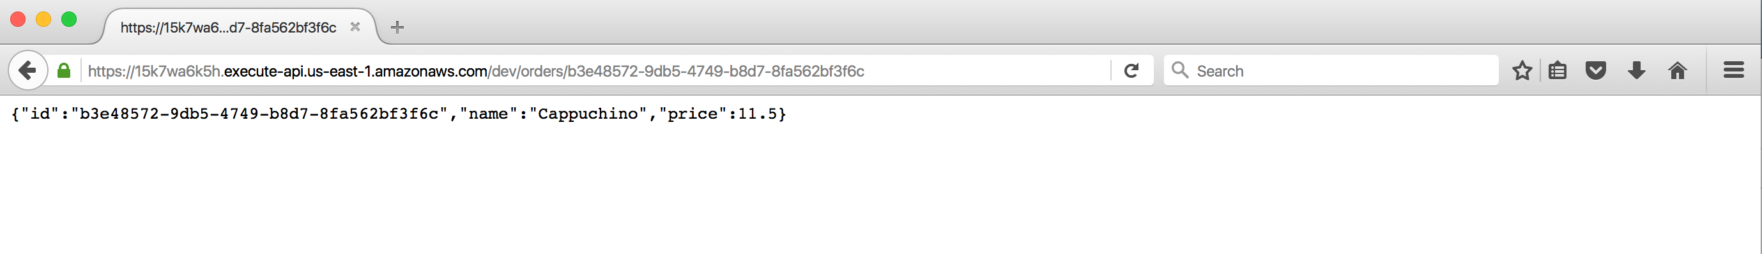

**Table created in the dynamodb table:**

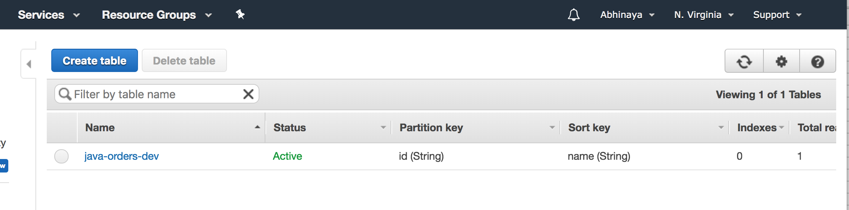

**Orders saved in the dynamo db table:**

